

School of Future Tech
Case Study Report
on
Shipping Container Tracking System (C++)
by
Anurag Kharke
150096725100

B.Tech CSE 2025–29 | C++ — Semester II | Case Study 87

Index
1. Introduction to the Case Study.
2. Problem Statement / Case Background (Abstract).
3. Problem Statement / Case Study Design.
4. Methods & Algorithms Technology Applied.
5. Implementation Details and Output Snapshots.
6. Results and Conclusion.
7. References

1. Introduction to the Case Study
In the modern global economy, shipping containers are the backbone of international trade. Efficient tracking of these containers is critical to ensure timely delivery, prevent cargo loss, and maintain supply chain transparency. Despite their importance, many logistics operators still rely on manual record-keeping that is error-prone and difficult to scale.
This case study focuses on designing and implementing a Shipping Container Tracking System using C++. The system provides a menu-driven console interface allowing users to register new containers, update locations, search by ID, display all records, generate status reports, and delete containers — with all data persisted to a text file.
The project demonstrates OOP concepts (classes, encapsulation, constructors), file handling with fstream, STL vectors, string parsing, input validation, and modular function design applied to a real-world logistics problem.

2. Problem Statement / Case Background (Abstract)
Background
Shipping containers require global tracking as they move between ports and hubs worldwide. Manual methods are slow and incapable of handling modern container volumes. A computerized system is needed to register containers, update locations, search records, and generate reports.

Abstract
This case study presents a Shipping Container Tracking System in C++ with seven operations: register (unique ID, origin, destination, location, weight, status), update location, search by ID, display all, status report, delete, and exit. Records are stored in a pipe-delimited text file (containers.txt) for persistence. The Container class encapsulates all data with getters/setters, and a vector<Container> provides dynamic storage with input validation at every entry point.

3. Problem Statement / Case Study Design
The system is designed as a modular console application with these stages:

1. Input Stage
- Menu-driven interface with 7 options; user selects an operation and provides required data.
2. Validation Stage
- Container ID must follow CTR-XXX format; duplicates rejected. Weight must be positive numeric. Status restricted to In Transit / Delivered / At Port.
3. Data Management
- Container class with private members and public getters/setters. vector<Container> for in-memory storage. Linear search O(n) for lookups.
4. Persistence
- Data saved to containers.txt (pipe-delimited) after every operation. Loaded on startup.
5. Output
- Detailed view for single containers, tabular view for all records, percentage-based status reports. Program loops until Exit.

The design uses only standard C++ headers, making it portable across all platforms.

4. Methods & Algorithms Technology Applied
1. OOP Design (Container Class)
- Private data members with public getters/setters. Default and parameterized constructors. toFileString() / fromFileString() for serialization.
2. Linear Search
- Iterates through vector comparing IDs. O(n) complexity. Used for search, update, and delete.
3. File I/O (fstream)
- ifstream reads at startup; ofstream rewrites after modifications. getline() + stringstream for parsing pipe-delimited data.
4. Status Report Aggregation
- Single-pass traversal with counters per category. Percentages calculated and displayed.
5. Menu Loop
- while(true) with switch-case. cin.clear() and cin.ignore() for error handling.

Technology Stack:
- C++ (C++11), Standard Libraries: <iostream>, <fstream>, <sstream>, <vector>, <string>, <iomanip>, <limits>. Compiler: g++ / MSVC / Clang. Data: text file with pipe delimiters.

5. Implementation Details and Output Snapshots
The system is implemented in a single CaseStudy87_150096725100.cpp file with: a Container class (6 private data members, getters/setters, display and file I/O methods), loadFromFile() and saveToFile() for persistence, validation functions (isValidID, isDuplicateID, getValidStatus), six core operation functions, and a main() with menu loop and switch-case dispatch.
An auto-generated containers.txt stores all records in pipe-delimited format for cross-session persistence.

Output Snapshots:
Figure 1: Compilation & Main Menu
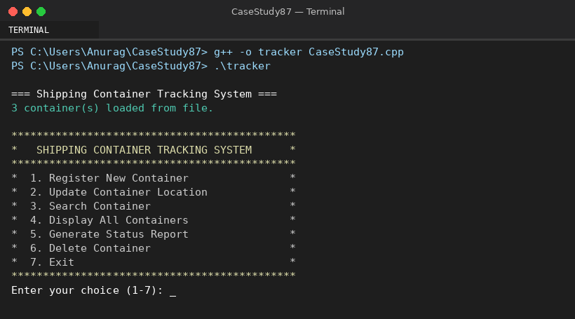
Figure 2: Registering a New Container
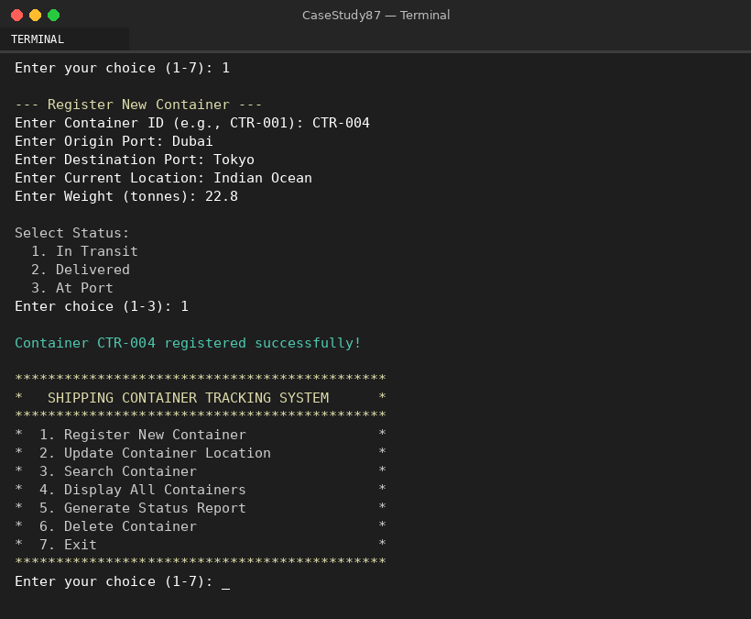
Figure 3: Display All Containers
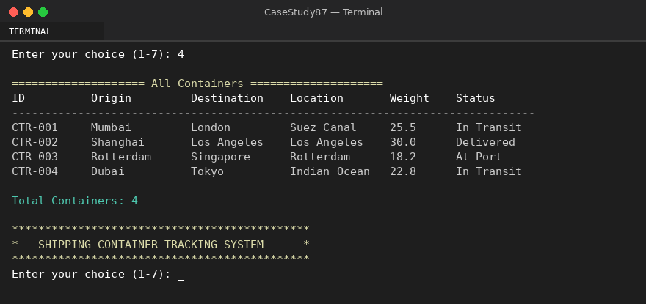
Figure 4: Search Container by ID
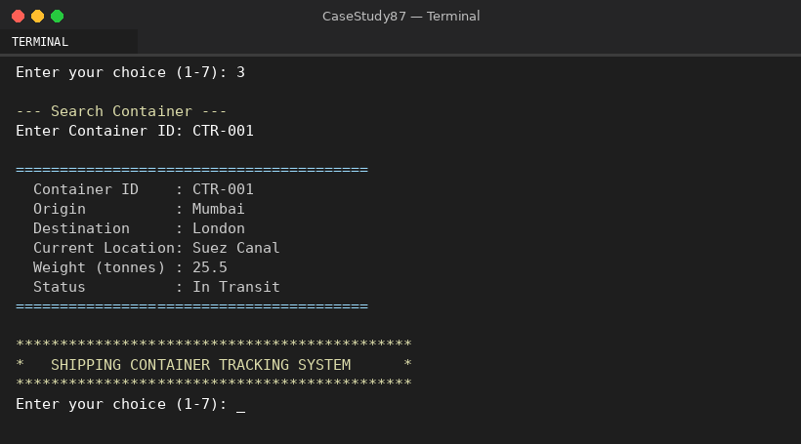
Figure 5: Status Report
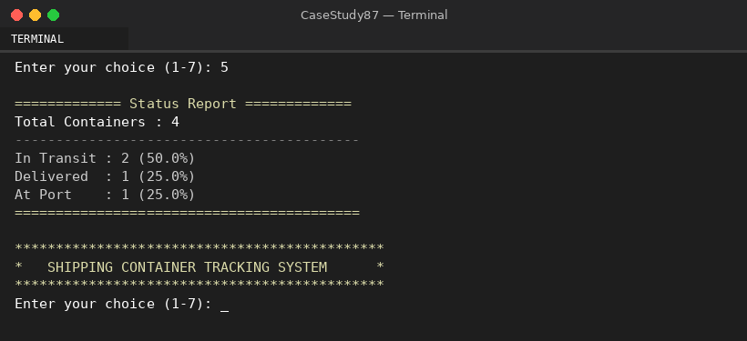
Figure 6: Update Location
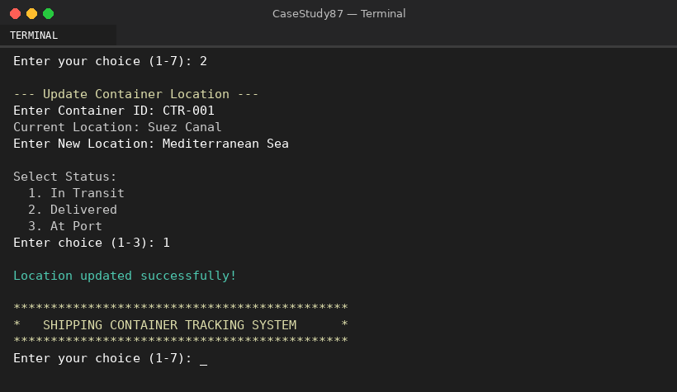
Figure 7: Delete Container & Exit
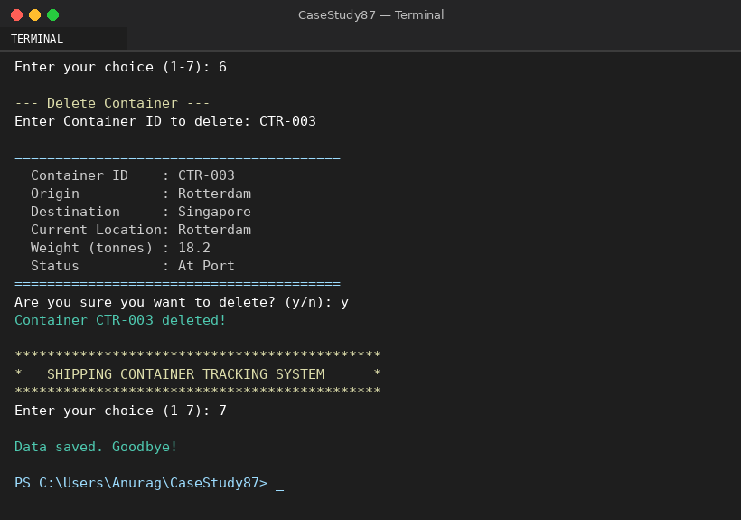
Figure 8: Data File (containers.txt)
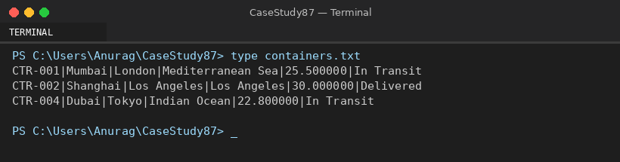

6. Results and Conclusion
Findings
- OOP encapsulation made the code organized, readable, and easy to extend.
- File-based persistence reliably retained data across sessions without database setup.
- Input validation at every entry point prevented runtime errors and ensured data integrity.
- Modular function design improved readability, reusability, and maintainability.
- Status report aggregation with percentages provided actionable logistics insights.

Conclusion
This case study demonstrates a complete Shipping Container Tracking System in C++, integrating OOP, file handling, STL containers, input validation, and menu-driven interaction into a practical application. The modular design forms a strong foundation for future enhancements such as database integration, GUI development, GPS tracking, and multi-user network access.

7. References
- C++ Standard Library documentation — cppreference.com.
- ISO/IEC 14882 — C++ Language Standard (C++11 and later).
- Stroustrup, B. (2013). The C++ Programming Language, 4th ed. Addison-Wesley.
- Lippman, S. B. et al. (2012). C++ Primer, 5th ed. Addison-Wesley.
- GeeksforGeeks C++ tutorials — geeksforgeeks.org.

— End of Case Study Report —

